Stainless Steel Hook Clamp With Latch Plate Size 700daN

Key Features
Overall Height: | 49.3mm
Length: | 314mm
Hook Diameter: | 12mm
Holding Force: | 700daN
Other Features
Weight: | 0.95Kg
Material
Toggle Clamp: | Stainless Steel
Hook: | Stainless Steel
Latch Plate: | Stainless Steel
What’s In The Bag?
Product Description
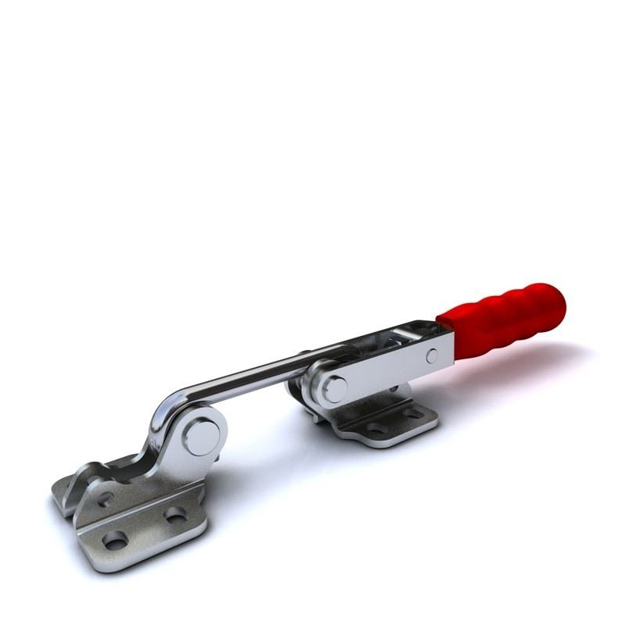

Toggle Clamp: | GH-40700-SS
Latch Plate: | GH-40700-LPSS

